# **Name: Abdurrahman Qureshi**

# **Roll No: 242466**

Practical No: 3

Date Of Performance: 22/07/2025

Aim: To understand and demonstrate the use of AWS S3

1. What is S3?
2. Explain uses of S3
3. Deployment of static website on AWS S3

[Screenshots and steps are required]

Ans 1:

Amazon S3, or Simple Storage Service, is a cloud-based object storage service offered by Amazon Web Services (AWS). It allows users to store and retrieve any amount of data, from anywhere, via the internet. S3 is highly scalable, durable, and secure, making it suitable for a wide range of applications

Ans 2:

Uses of S3:

**1. Data Storage & Backup**

- Store files (documents, images, videos) in buckets.

- Automate backups with **S3 Lifecycle Policies** and **Versioning**.

**2. Static Website Hosting**

- Host static websites (HTML, CSS, JS) directly from S3.

- Integrate with **CloudFront** for CDN acceleration.

**4. Big Data & Analytics**

- Store logs, datasets for analysis with **Athena, Redshift, EMR**.

- Supports **Parquet, CSV, JSON** formats.

**5. Application Data & Media Storage**

- Store app assets (user uploads, thumbnails).

- Serve media files via **S3 + CloudFront**.

**6. Disaster Recovery (DR)**

- Cross-region replication (**S3 CRR**) for failover.

- Store critical backups offsite.

**7. DevOps & CI/CD**

- Store build artifacts (Docker images, Lambda code).

- Use with **AWS CodePipeline, CodeBuild**.

**8. Security & Compliance**

- **Encryption (SSE-S3, SSE-KMS, SSE-C)** for data protection.

- **Access Control (IAM, Bucket Policies, ACLs)**.

- **Audit logs** via **AWS CloudTrail**.

**10. Hybrid & Multi-Cloud Storage**

- **AWS Storage Gateway** for on-premises access.

- **S3-compatible APIs** for multi-cloud use.

Ans 3:

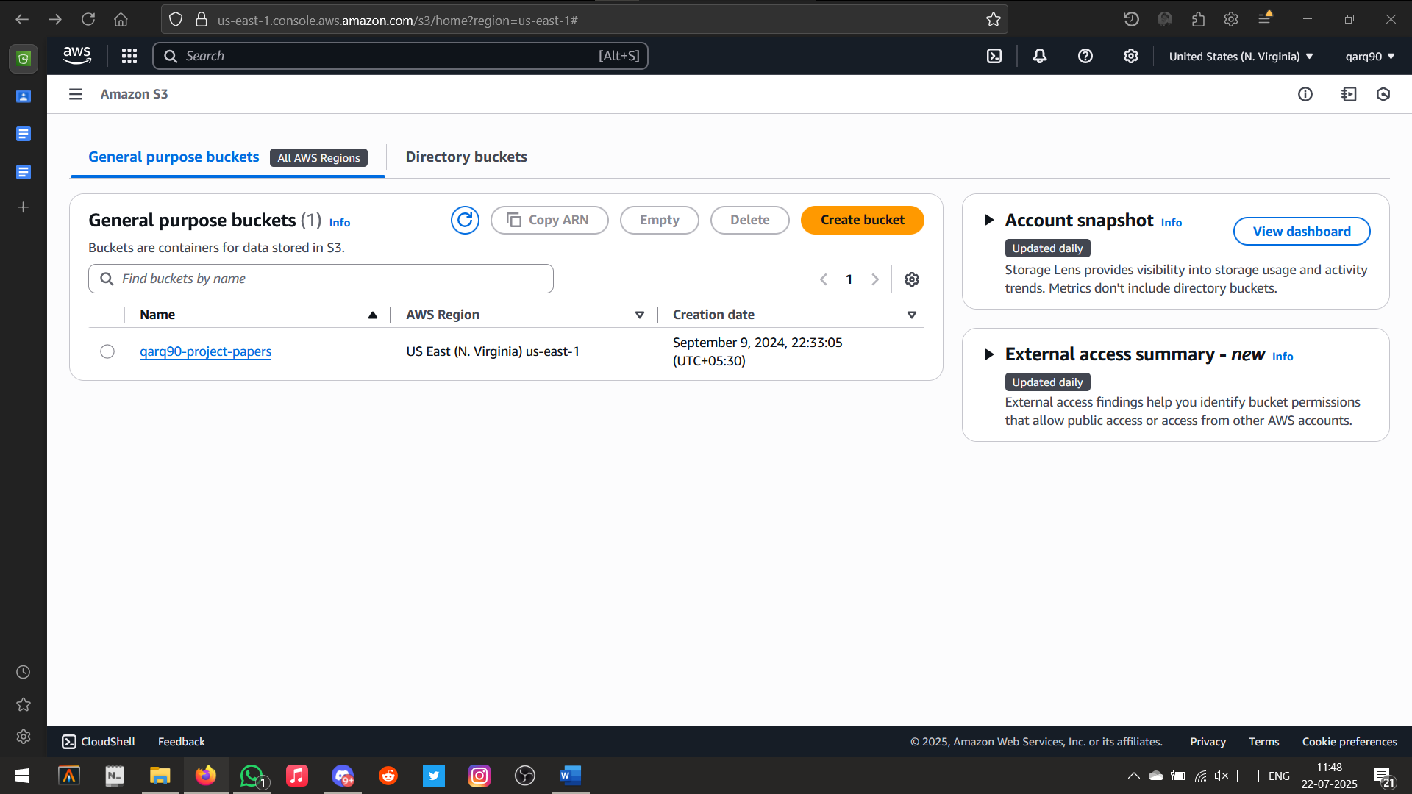

Opened S3 Buckets Page

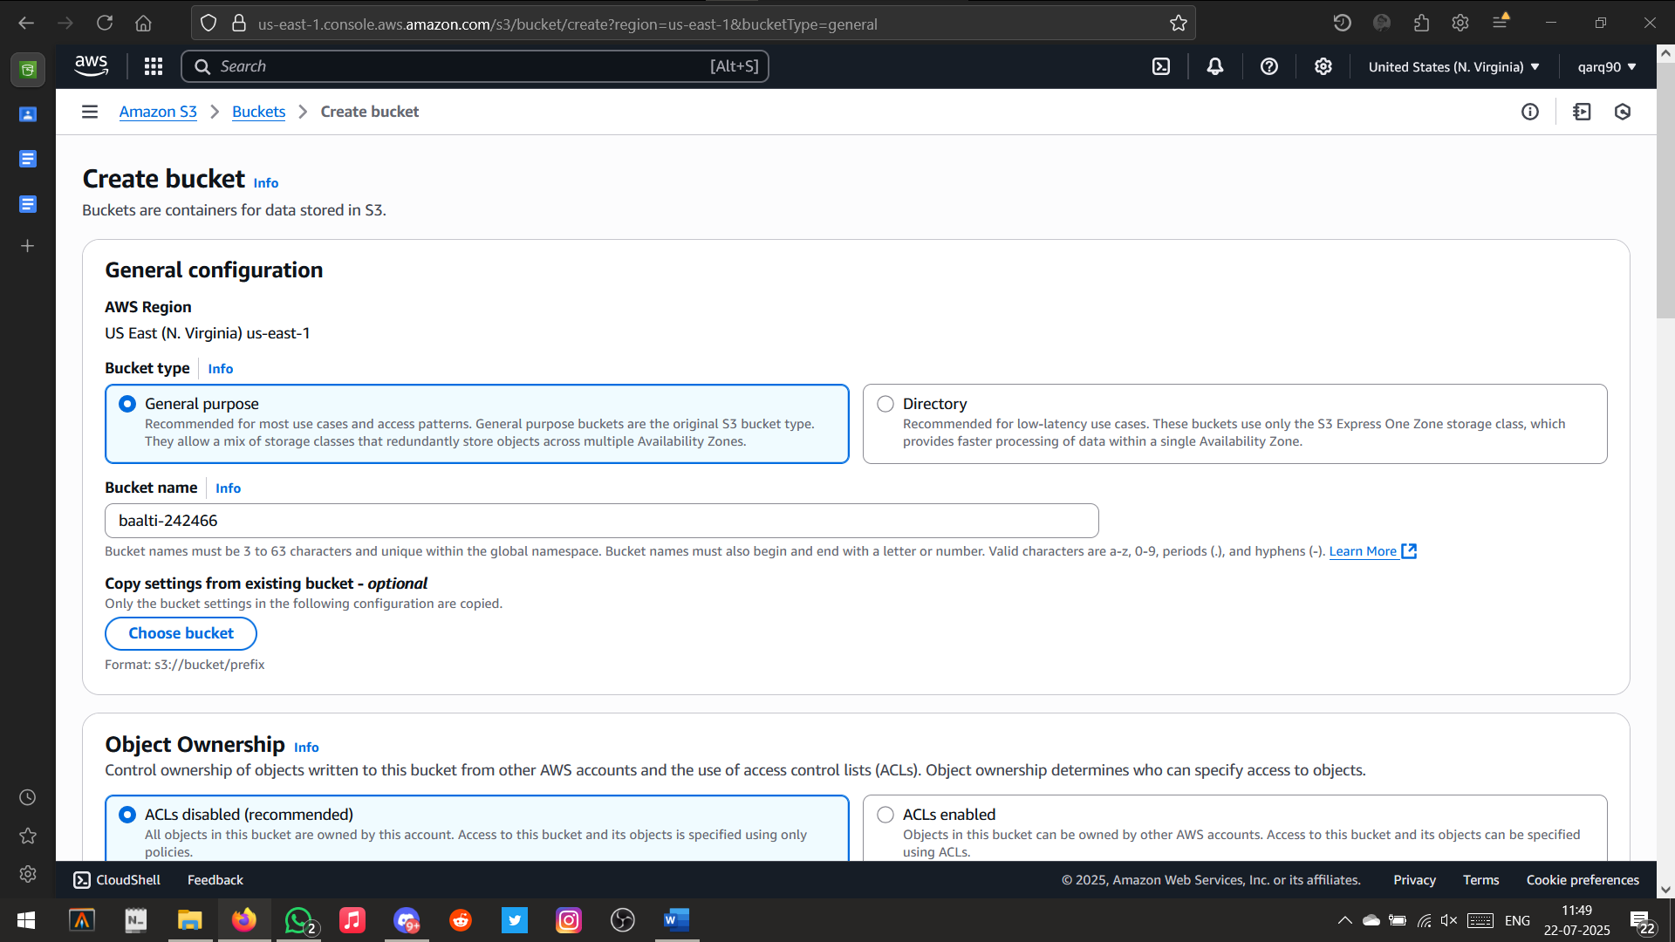

Setting bucket name

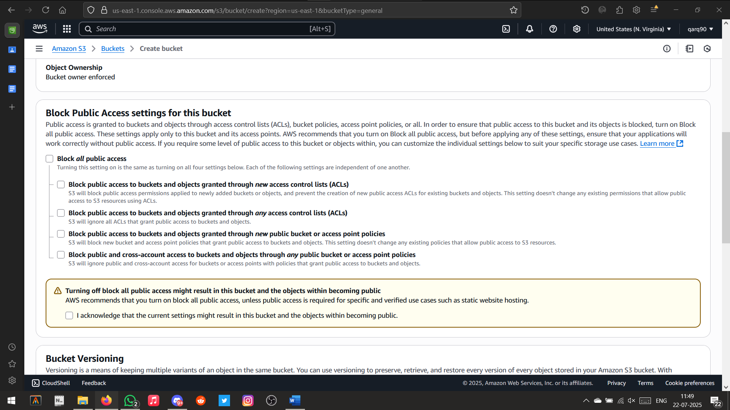

Policies for public access

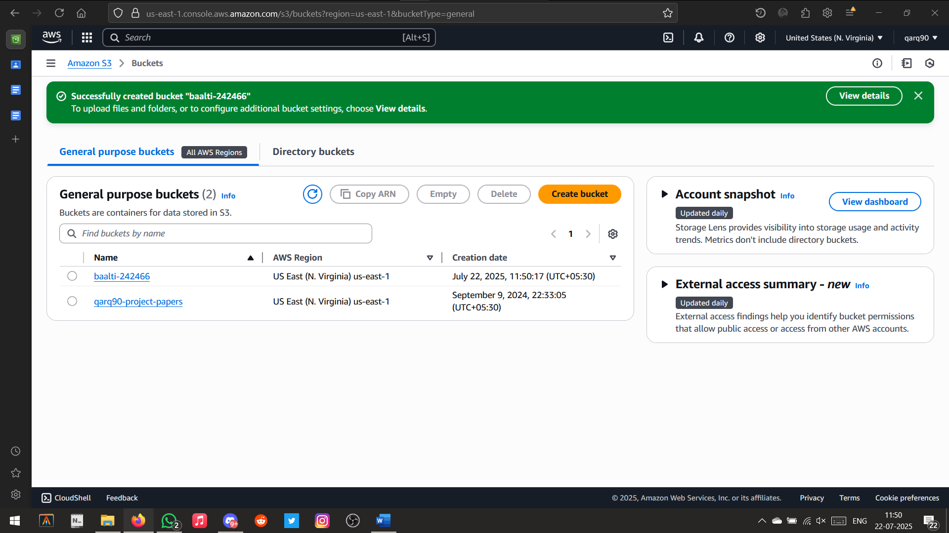

Bucket created successfully

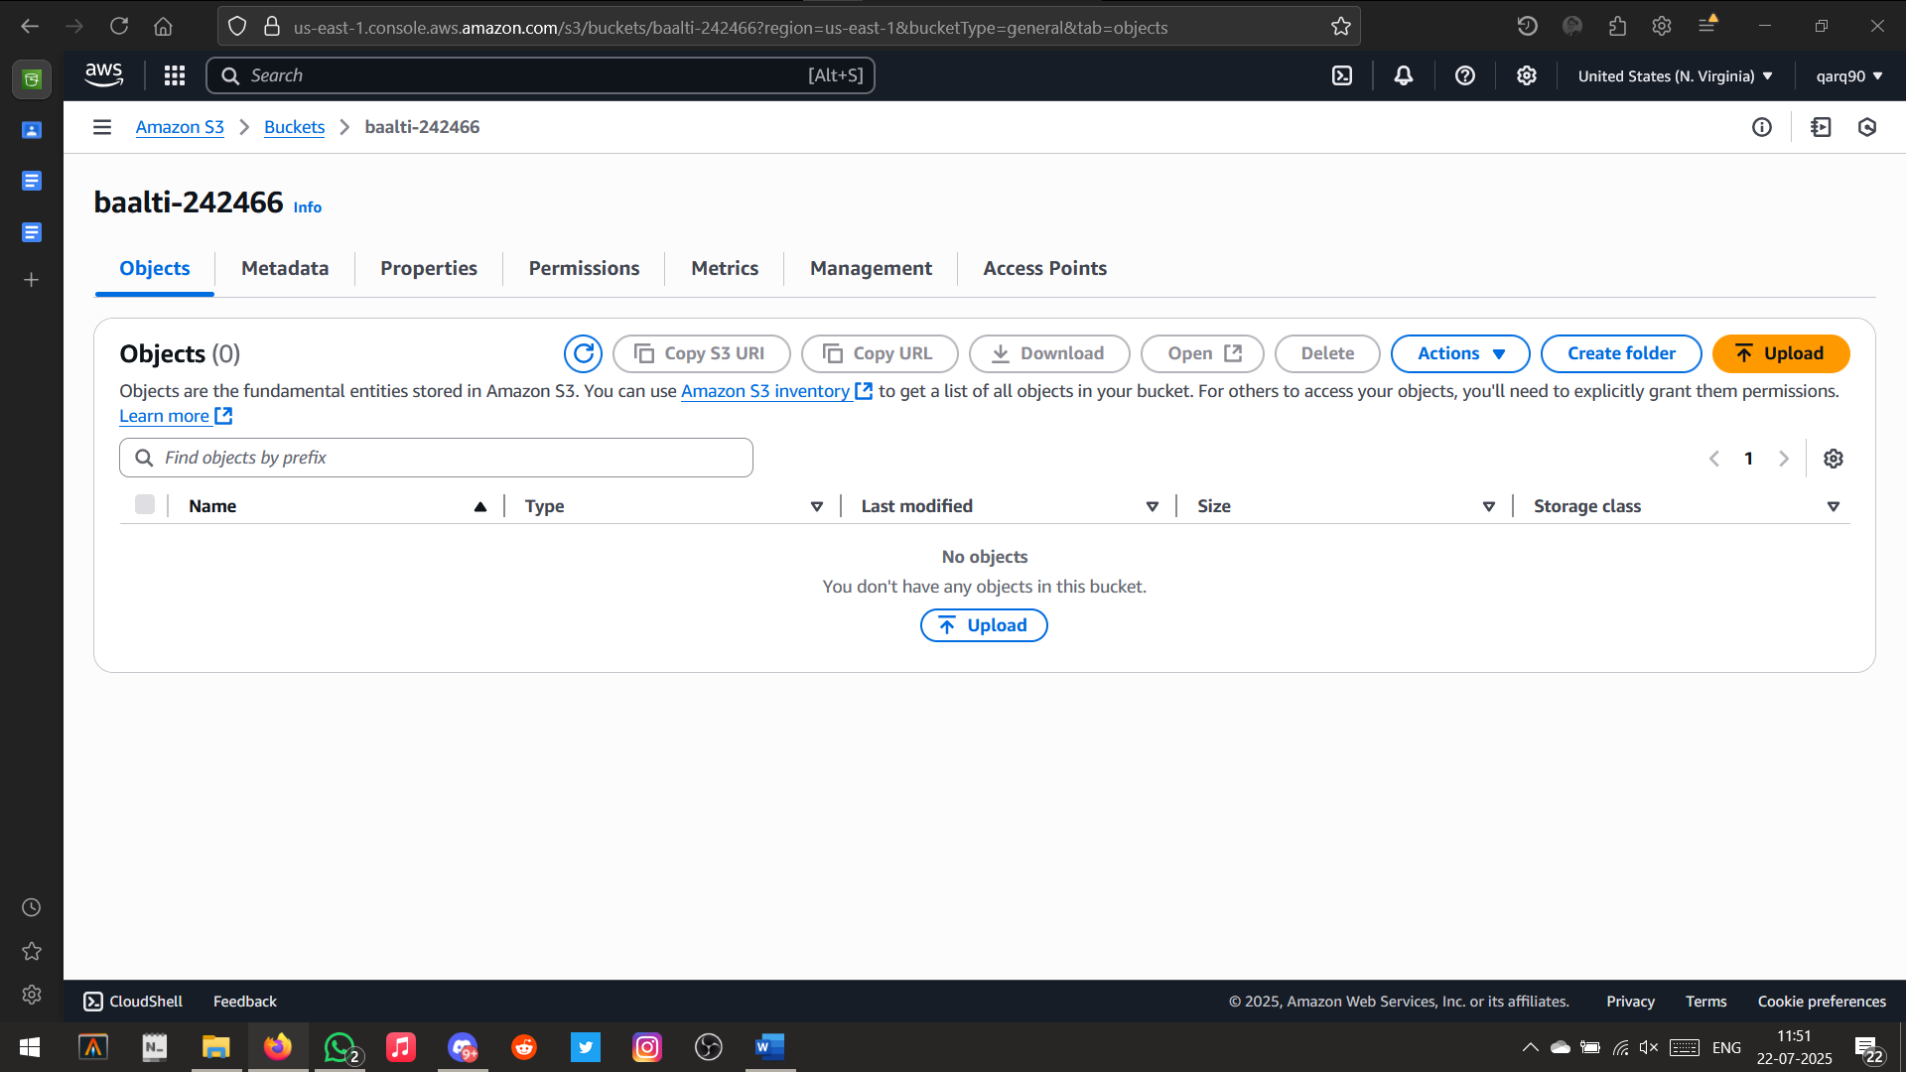

Opened ‘baalti-242466’bucket

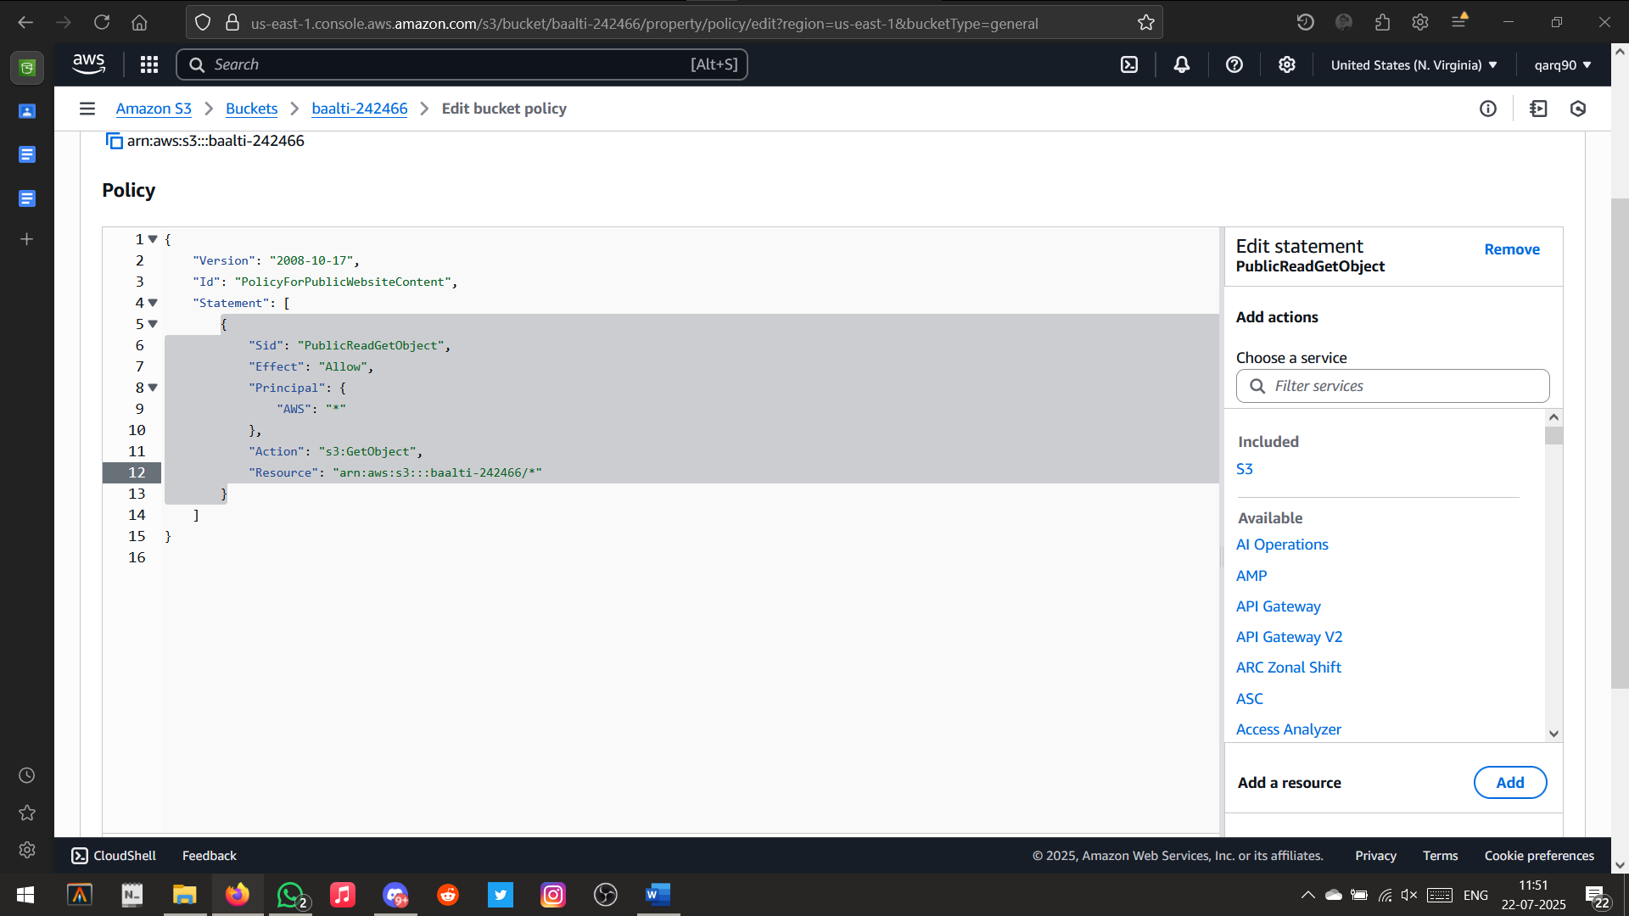

Setting up the bucket policies

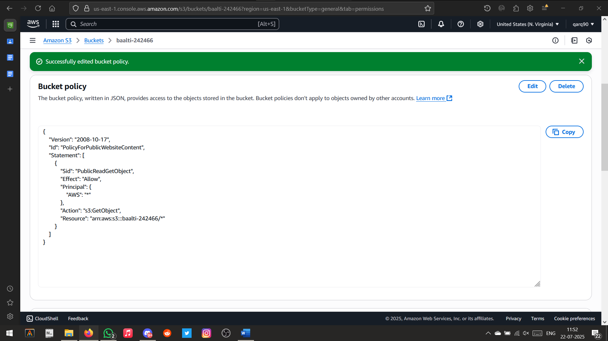Policies Updated Successfully

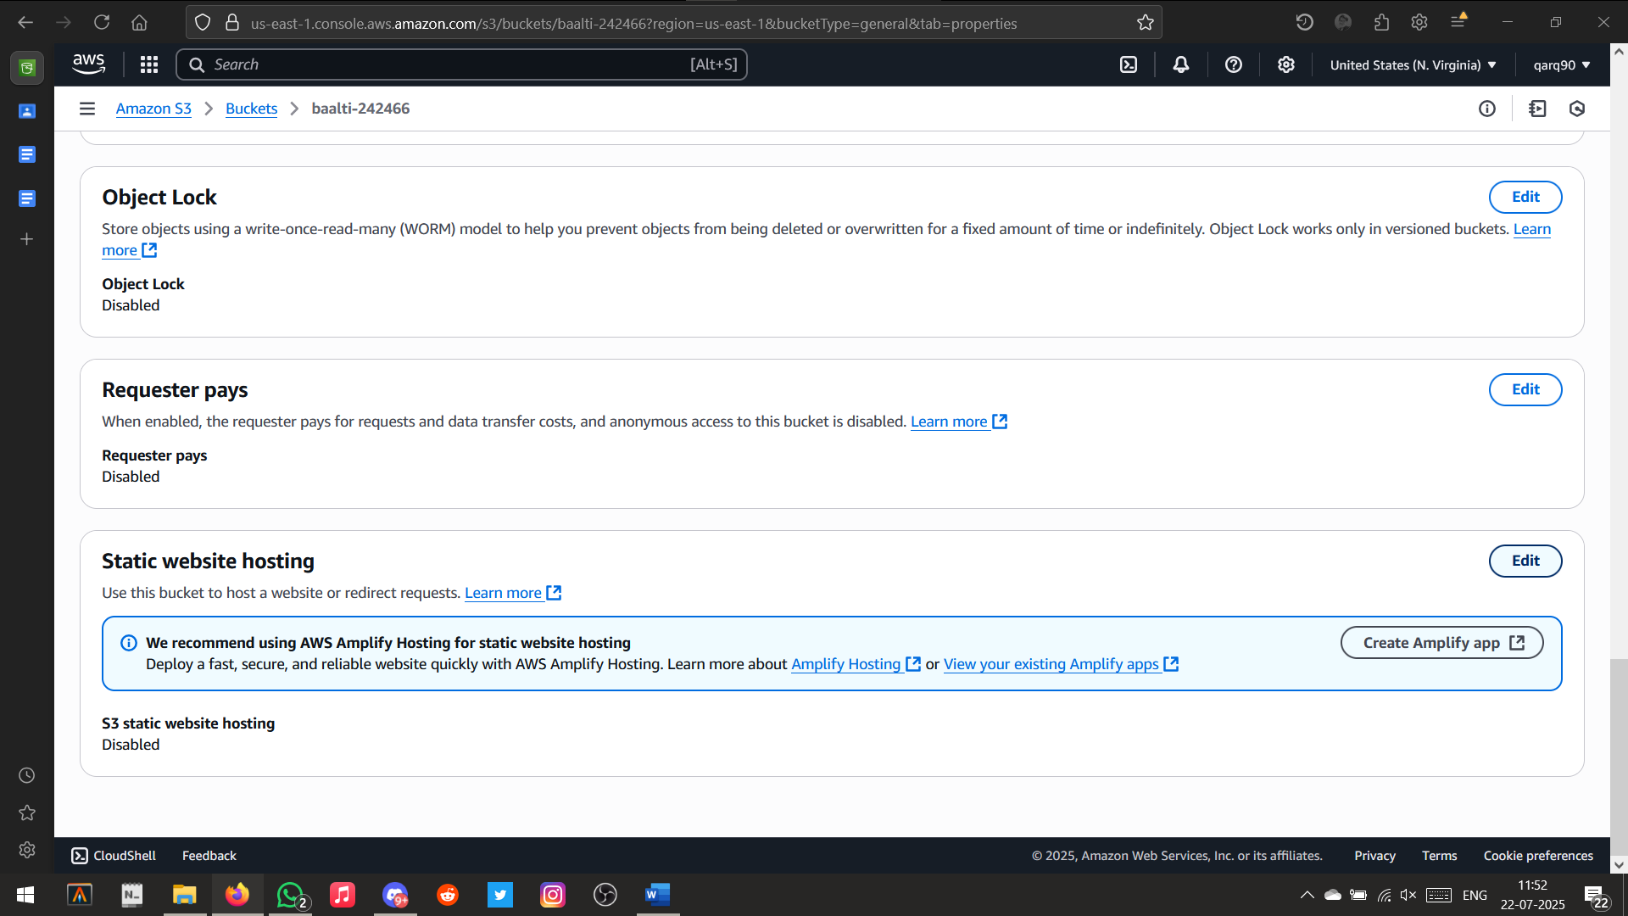

Setting up static website hosting policies

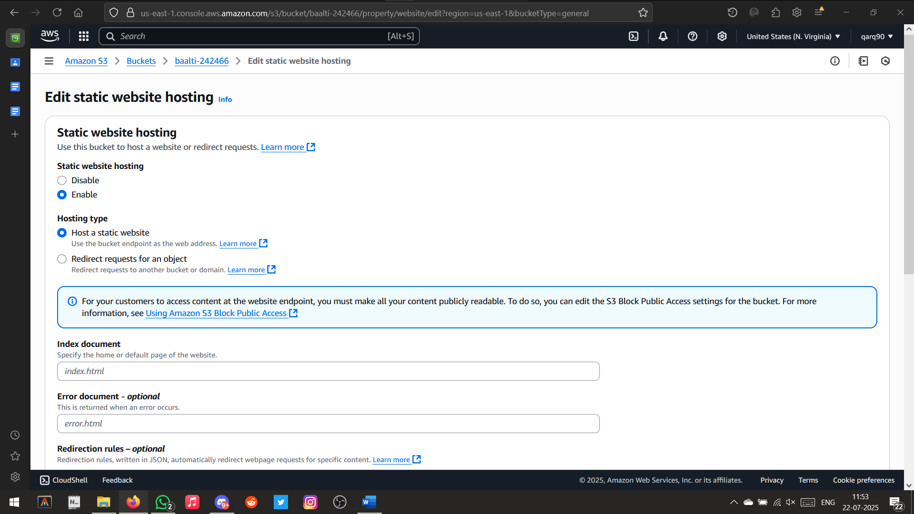

Allowing static website hosting

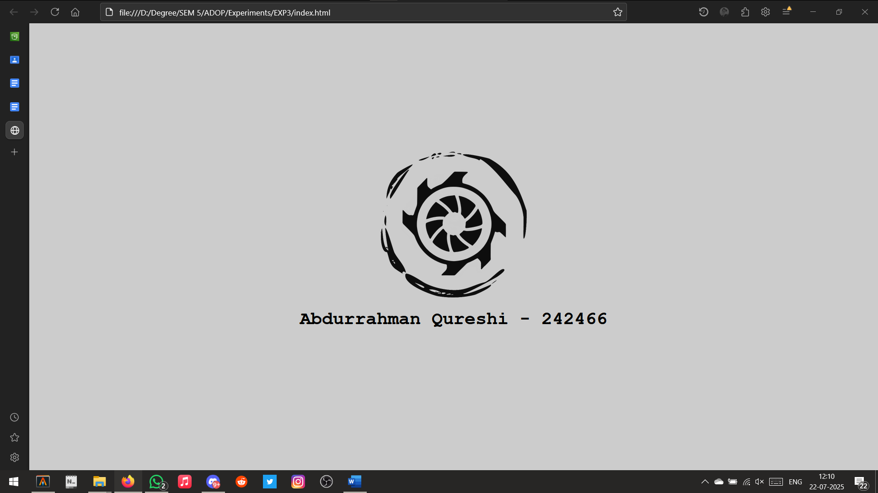

Static Page created

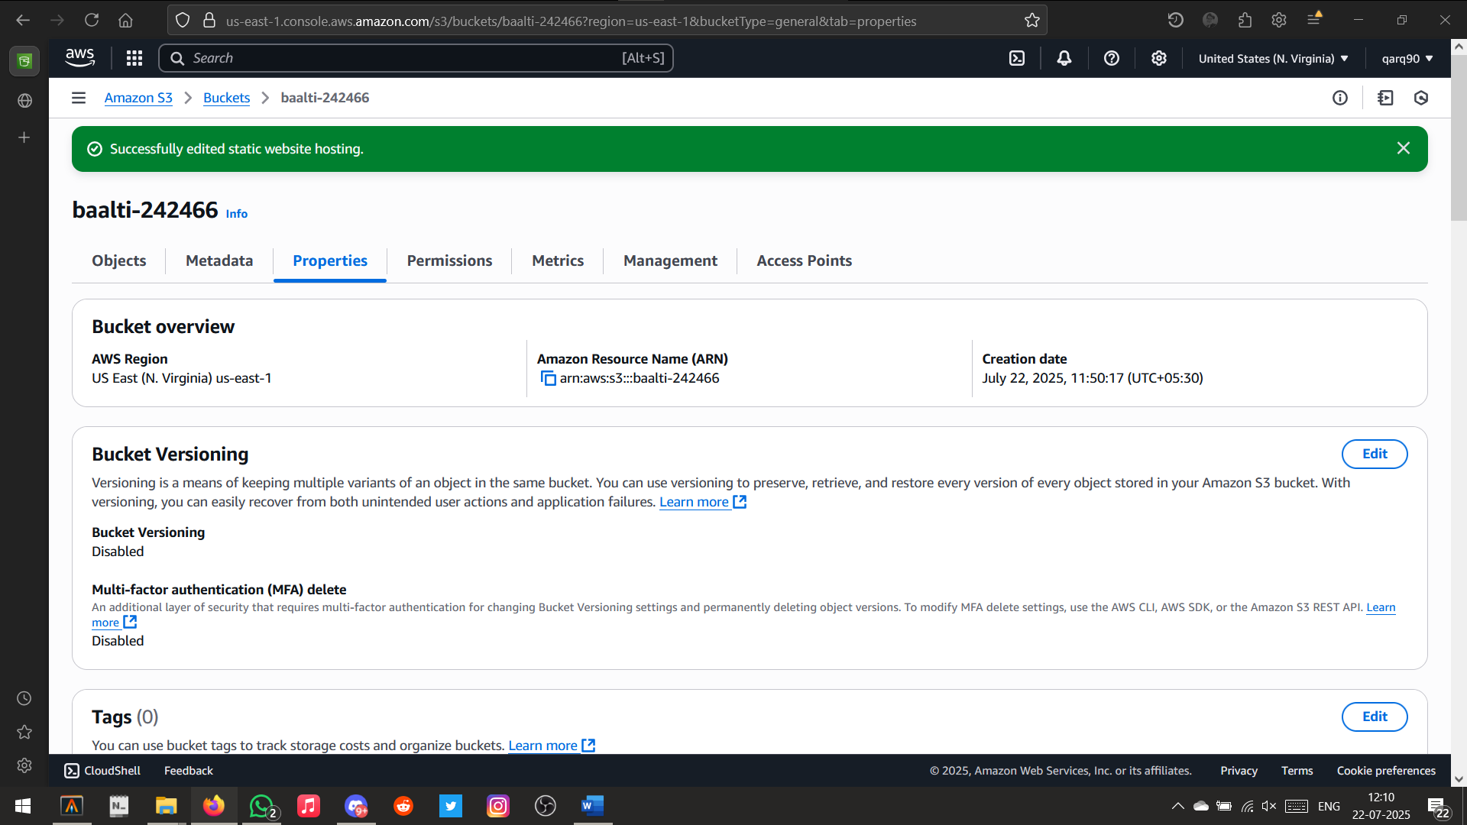

Successfully edited static website hosting

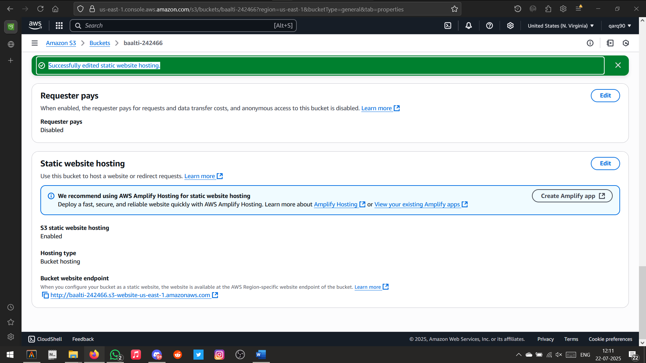

Hosted URL

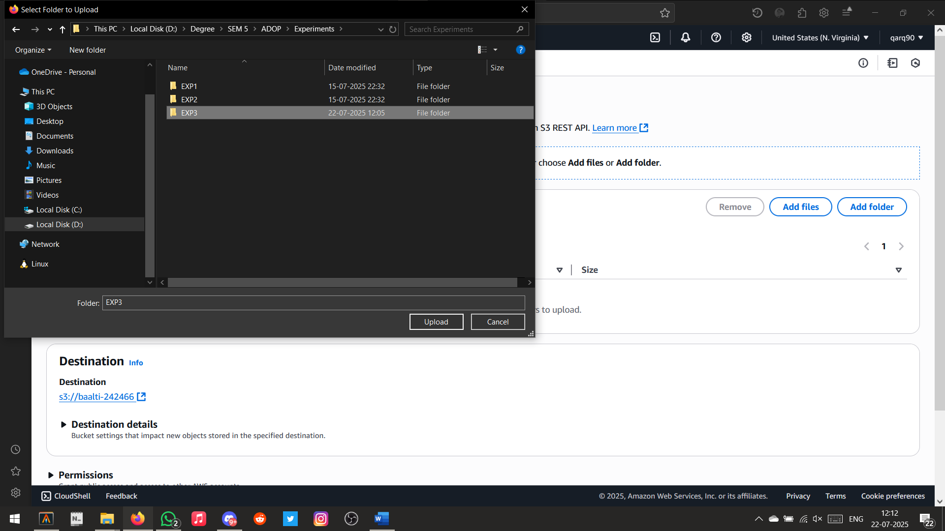Uploading website code

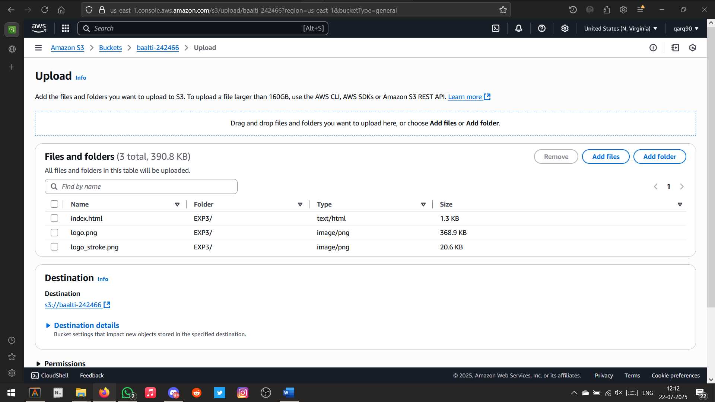

Files Uploaded Successfully

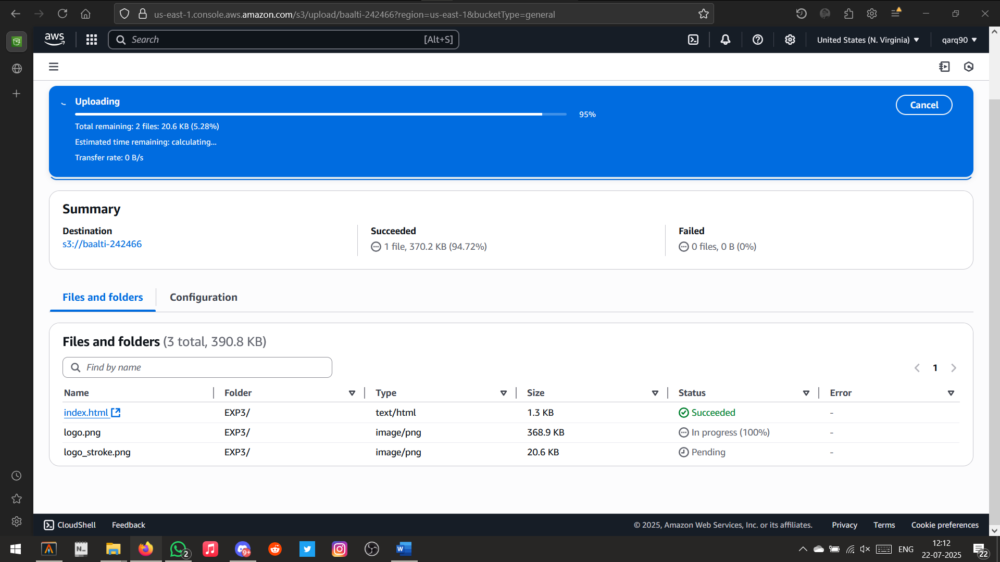

Uploading Files

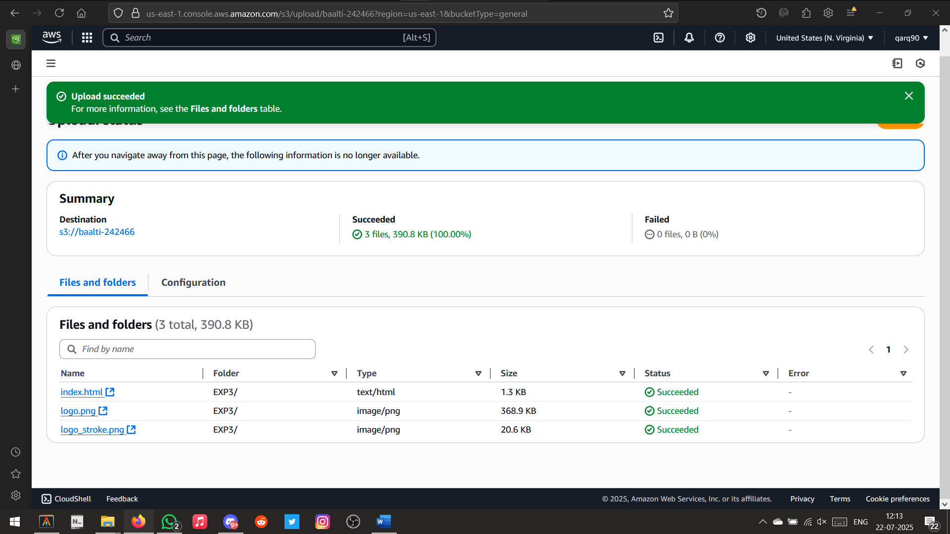

File uploaded Successfully

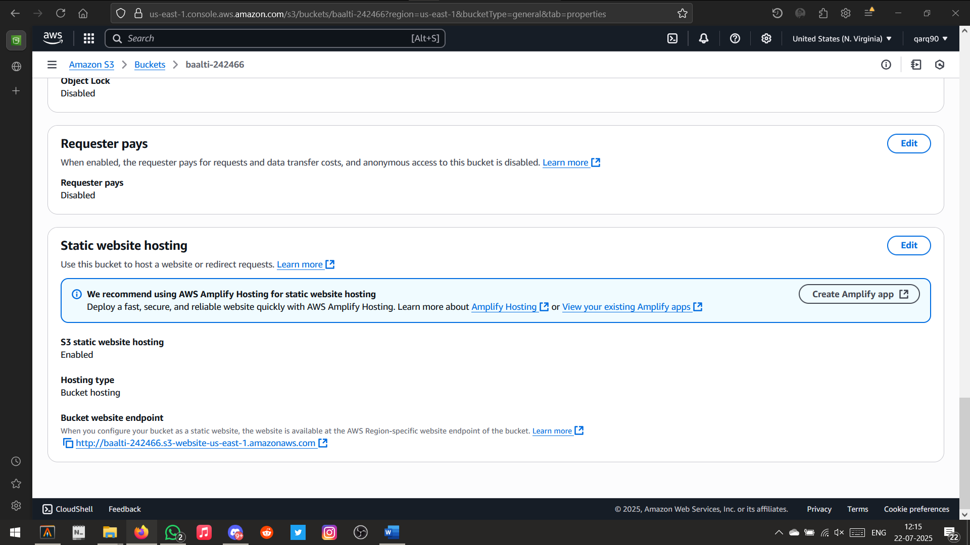

URL Generated

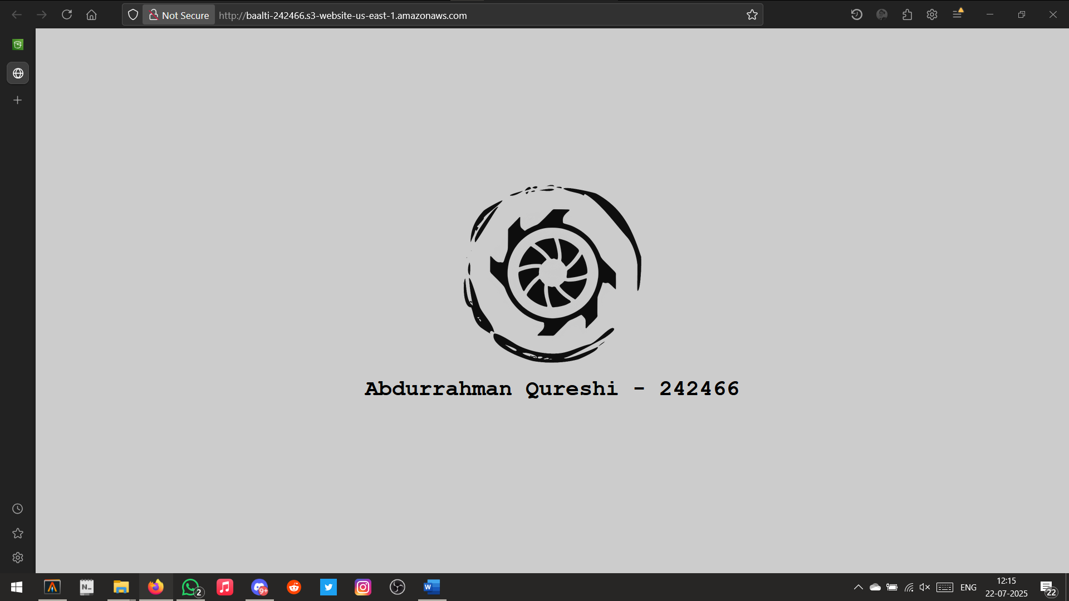

Deployed Website